TREE REPORT 2023

– DESCRIPTIONS AND DETAILS

Coed Hills Rural Art Space has now over 1000 extra trees planted around the site thanks to the volunteers and sponsors during 2022/2023.

Trees purchased:

COED Y TOR (Nancy Evans)

600 trees of:
Elder, Alder, Rowan, Hawthorn, Cherry Plum, Field maple, Sweet Chestnut, Crab Apple, Wild Cherry, Damson, Wych elm, Common Pear, Downy Birch, Silver birch, Hazel and Oak.

https://www.facebook.com/CoedYTorTrees

FPM TREE NURSERY

Hedging trees: 400 beech trees.

EDICULTURE

Planted in the Stone Circle Field

Many types of Apples (80 trees in the stone Circle)

AGROFORESTRY RESEARCH TRUST

Planted in the Stone Circle Field

20 chestnuts

PLANTING WEEKENDS
from JAN 2023 – to FEB 23

First planting Weekend –
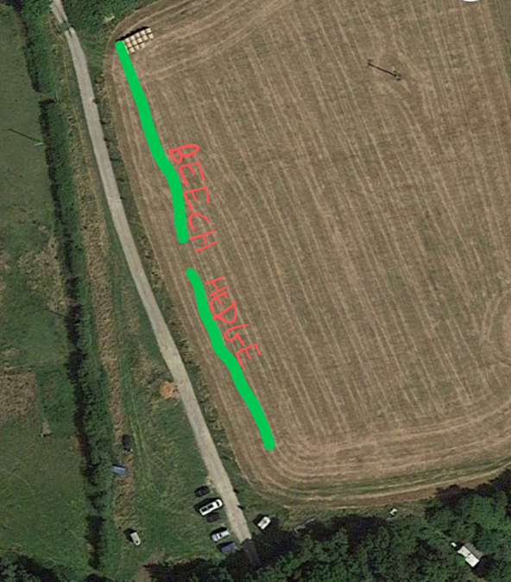

20 people ish, 400 + trees into hedge, 2 m wide. Trees from Frank P Matthews.

Second planting weekend

A shelterbelt in the Stone Circle Field. 7m wide.

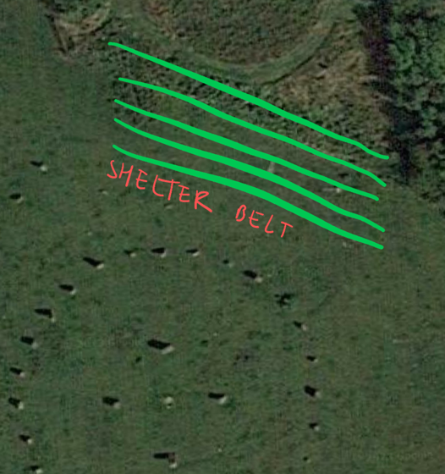

15 volunteers from the Cardiff Uni, plus community.

250 or so trees planted. Trees from Coed Y Tor.

3rd Planting weekend

Another shelter belt – 4m wide.

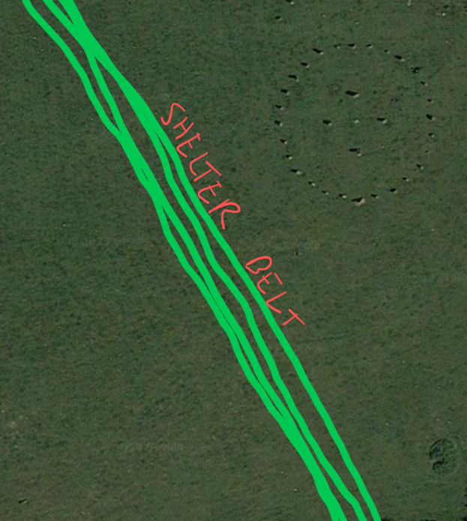

This is the west edge of the stone circle field. Trees from Coed Y Tor. 400 or so planted.

4th Planting weekend
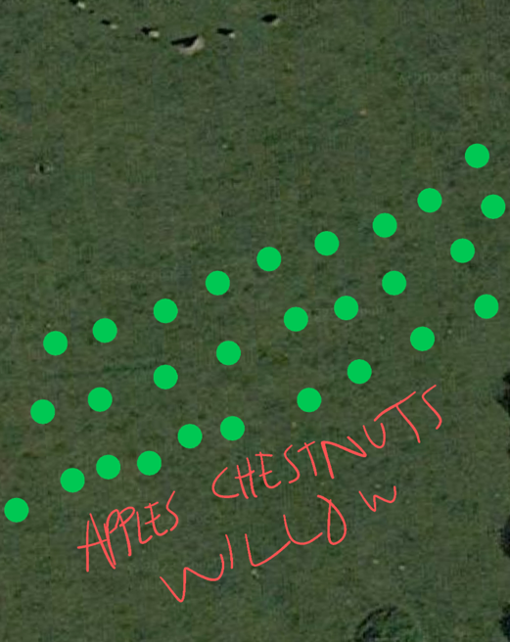
This was a mix of apples, Chestnut and willow planted to the south of the stone circle. Trees from Ediculture and the Agroforestry Research Trust.

5th planting weekend

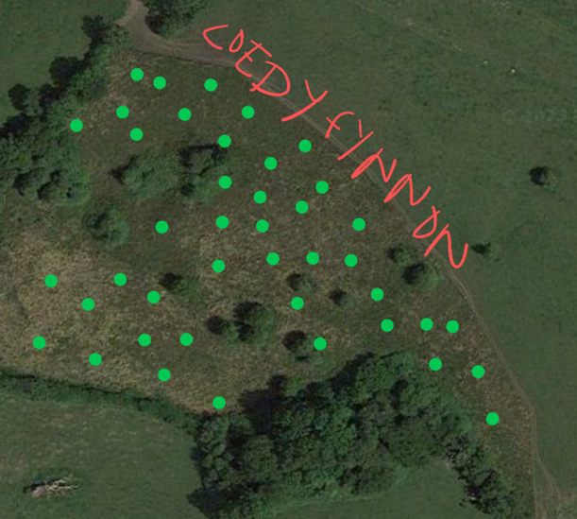
– trees from Coed Y Tor, and Ediculture and Greg Willow. Here we went through our planting of trees in 2020 and replaced any dead trees, took off the old tree guards, and mulched new and existing trees with more woodchip.

6th planting weekend

– final planting weekend on 25th Feb.

Here we inserted into the general site of Coed the following:

Chimonanthus praecox – winter sweet
Daphniphyllum macropodum
Clerodendrum trichotomum
Staphylea pinnata
Vaccinium corymbosum
Vitis labrusca Concord
Ficus carica 'Scone' - Figtree Scone
Distylium racemosum - Isu Tree
Crinodendron patagua
Cotoneaster bullatus
Corylopsis sinensis
Fragrant winter hazel
Caryopteris incana
Camellia japonica
Decaisnea fargesii
Diospyros virginiana
styrax japonicus
Styrax formosanus
Styrax obassia
Sapindus mukorossi
Sophora tetraptera
Sophora microphylla
Magnolia sieboldii
Maackia amurensis
Virginian Witch Hazel
Japanese Medlar
Diospyros lotus –
Cornus capitata
Cercis siliquastrum
Catalpa bignonioides
Aronia prunifolia
Araucaria araucana – monkey puzzle.
albizia julibrissin - silk tree –
Aesculus turbinata
Japanese horse chestnut.
Aesculus indica
Indian horse chestnut
Aesculus parviflora - Bottle brush
Actinidia arguta Ananasnaya
Acca sellowiana
Acacia dealbata

These were grown in pots from last years purchases from Jurassic plants (see planting description 2021/22). As the trees were too small to plant out we needed to grow them on for a year. They have now been put into their final positions. They were dotted all around the site into suitable positions.

Where we are at now…

Many thanks as ever to our supporters Orchard Media.

We wish to turn the entire 180 acres of Coed into an ecological demonstration site for sustainability and regeneration of natural ecosystems. Whilst planting trees is a part of this, we know that it involves much more than just planting trees. So we have got grants to dig some new ponds to address water management on site, holding the water so that other species can find habitats. We are also increasing our output of food growing year on year, as we develop the top ten acre field into a horticultural site for growing vegetables and fruit. Ediculture will also be using this site for teaching and running courses.

We intend to create a shelterbelt around the whole land of Coed, creating a wild-life corridor for various species to move along, and live within. Our next years planting will be tackling this wider edge of the Coed land, down along the south edge of the land towards the road and along the west edge towards the village. We will also be planting up more trees around the ponds that will be dug, and planting more apples to increase our local fruit production.

