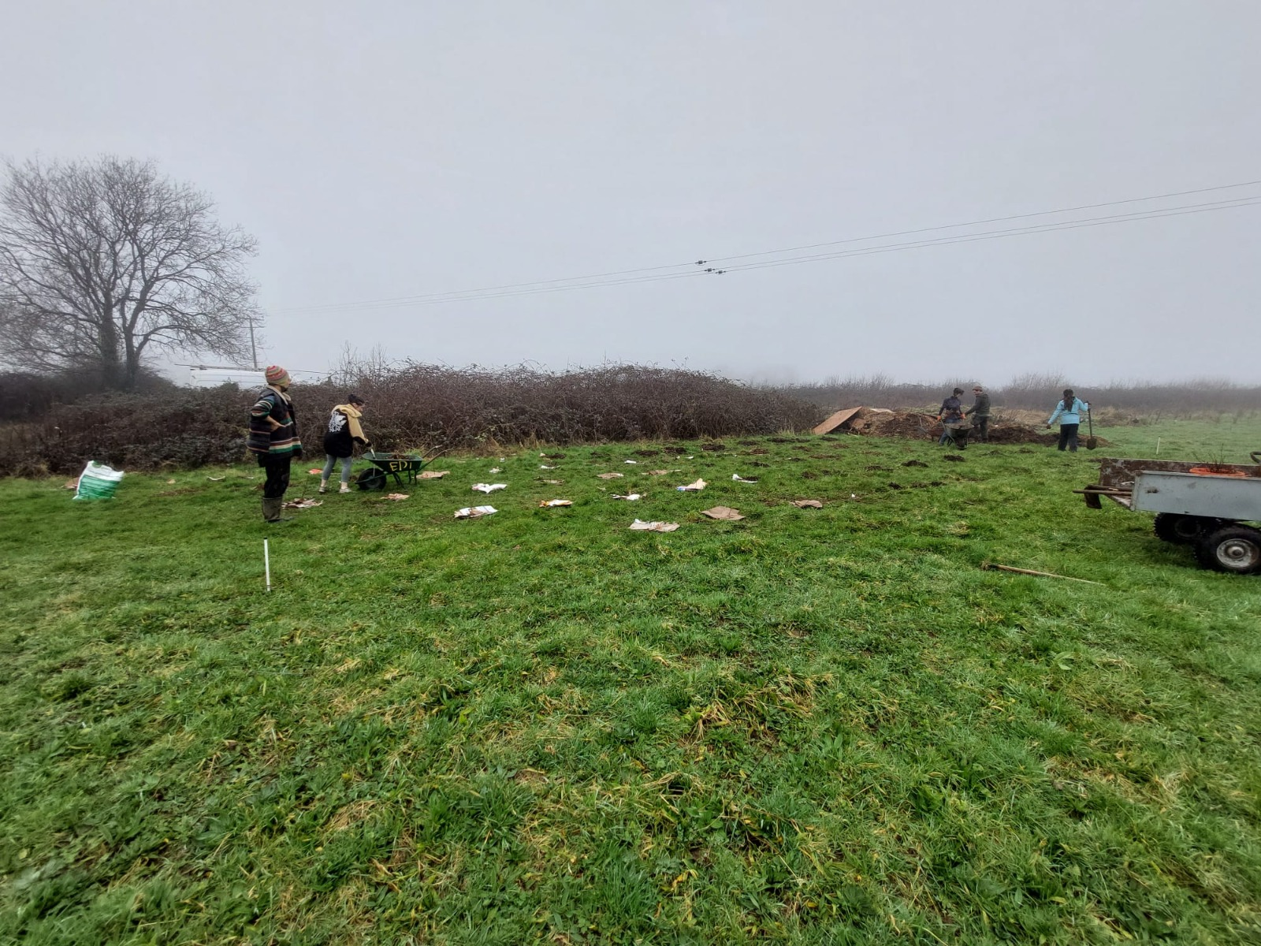

Tree Planting Project 2023/2024 Report
Extending our gratitude to the sponsors and volunteers who have helped
plant over 470 trees and support the developing growth of another 1000+ trees
during Winter 2023 and Spring 2024!

Days of planting
This year we have been doing a lot more tree care, consolidating the plantings from the two previous year’s plantings –
The first day we engaged with tree care was all the way back on the 30th September 2023 – we were not planting, but we did a day on mulching the fruit trees that were planted on the previous years – helping spread woodchip and old sheep’s wool dropped off from a local farmer, with the help of the Jujitsu volunteers –
Then we did an apple day celebration on the 1st of Oct.
The first tree planting weekend began on 4th November, as part of a wider event – the Coed Cauldron (see poster attached)
The next was on the weekend 16th – 17th December also as part of a wider event – Winterise (see poster attached)
Then into the new year we ran tree planting on 13th, 20th & 27th of January, 18th and 25th of Feb and the 2nd of March.
totalling 10 days of planting and tree related activities. These weekends were enjoyed by many of the Coed residents plus about 30+ volunteers as we joined together to create greener spaces around the site of Coed Hills Rural Art Space.
We collaborated these plantings with the Jujitsu club from Cardiff Uni. It was incredibly helpful having them turn up for a number of the planting days and we could not have achieved so much without their generous and youthful energy.
The weather was undoubtedly a big challenge, one of the wettest winters on record! Still we managed to plant loads of trees and engage dozens of people in the planting.
Actions – Timeline and people involved.
Day 1 - 30th September – Mulching 80 fruit trees with straw, woodchip and sheep wool plus mulching the beech hedge with old hay. 17 people were involved with the planting.
Day 2 - 1st October – Apple day. Over 100 people turned up for apple day, got involved with juicing, tasting apples and apple games.
Day 3 – 4th November – Coed Cauldron event – Planting 100 beech trees as a hedge down the drive. Mulching these trees with old hay and woodchip. 20 people helped with the planting.
Day 4 and 5 - 16th – 17th December – Winterise event. Fruit Tree planting - planted a new orchard of 50 apple trees, about 30 varieties, mulched with woodchip and staked in the bottom of the stone circle field. 15 people helped plant.
Day 5 – 13th January - planted a chestnut coppice in the ten acre field. 8 people helped with the planting.
Day 6 – 20th January - planted another strip of trees to an existing shelterbelt in the stone circle field. 11 people helped with the planting.
Day 7 – 27th January – planted a mix of trees at Coed Y Fynnon – birch, bird cherry, rowan, field maple and hawthorn. 8 people helped with the planting.
Day 8 – 18th February – Planted another shelterbelt in the stone circle field. 6 people helped with the planting.
Day 9 - 25th February – mulched the trees in the shelterbelt along the edges of the stone circle field– We decided that they needed a second load of woodchip. 13 people helped with the planting.
Day 10 - 2nd March – Planted more trees at Coed y Fynnon, and mulched the trees with hay. 10 people helped with the planting.

We were blessed this winter season with the Jujitsu Club volunteers who made it out to most of the tree planting days. We could not have done it without their effort! We were also very grateful to the covered forest school area which gave us shelter and a fire place to warm ourselves during lunch. The cold wet winter days were a challenge as ever, physically exhausting, and needing all the help we could get!
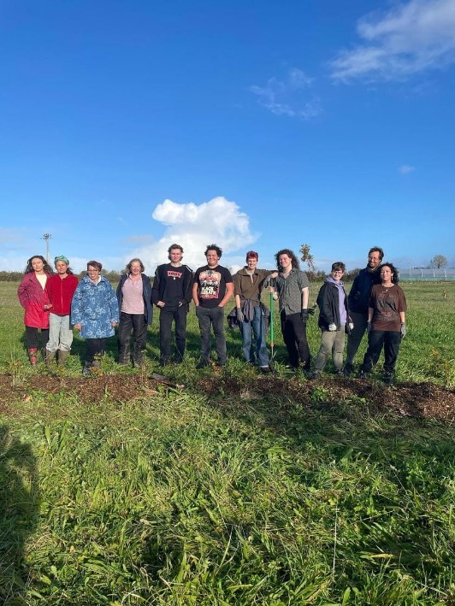
The Jujitsu club from Cardiff University
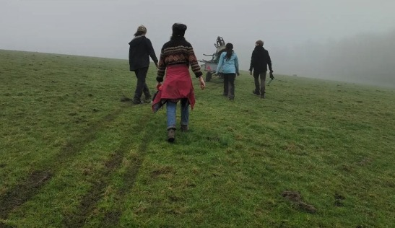
The weather!

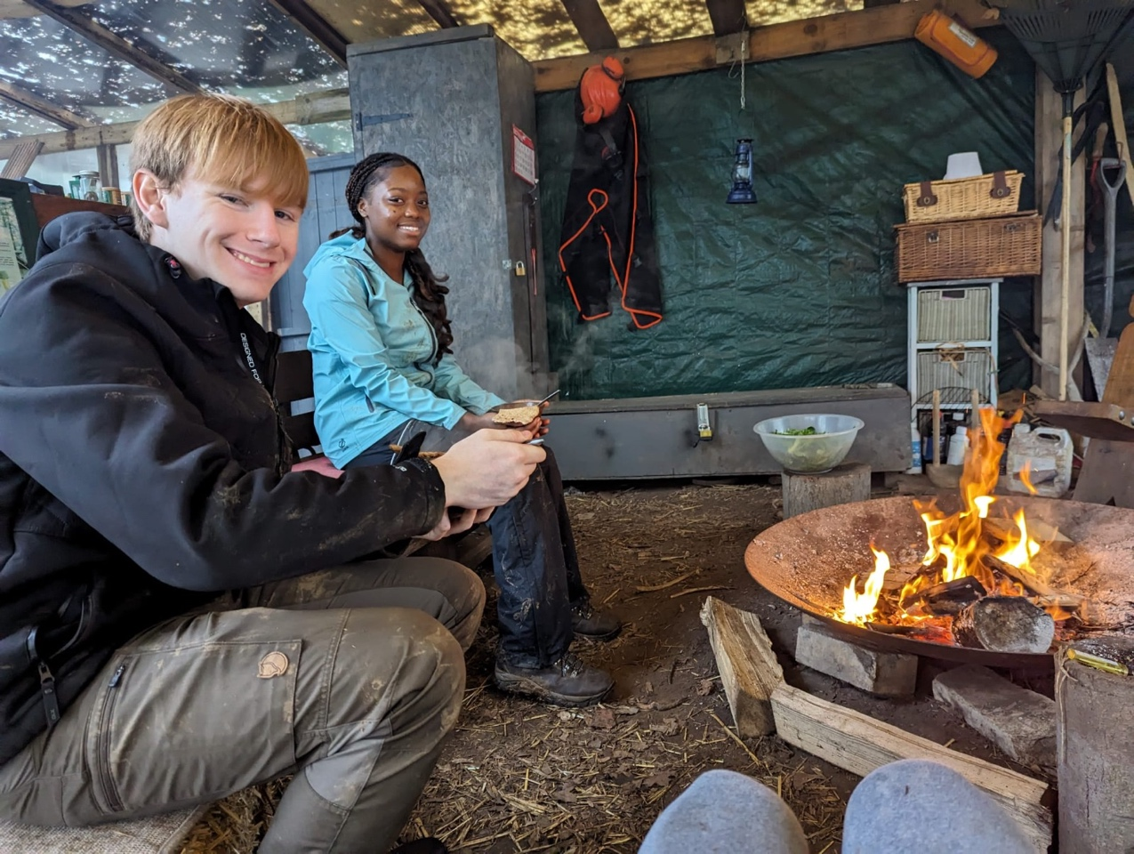
Stopping for lunch
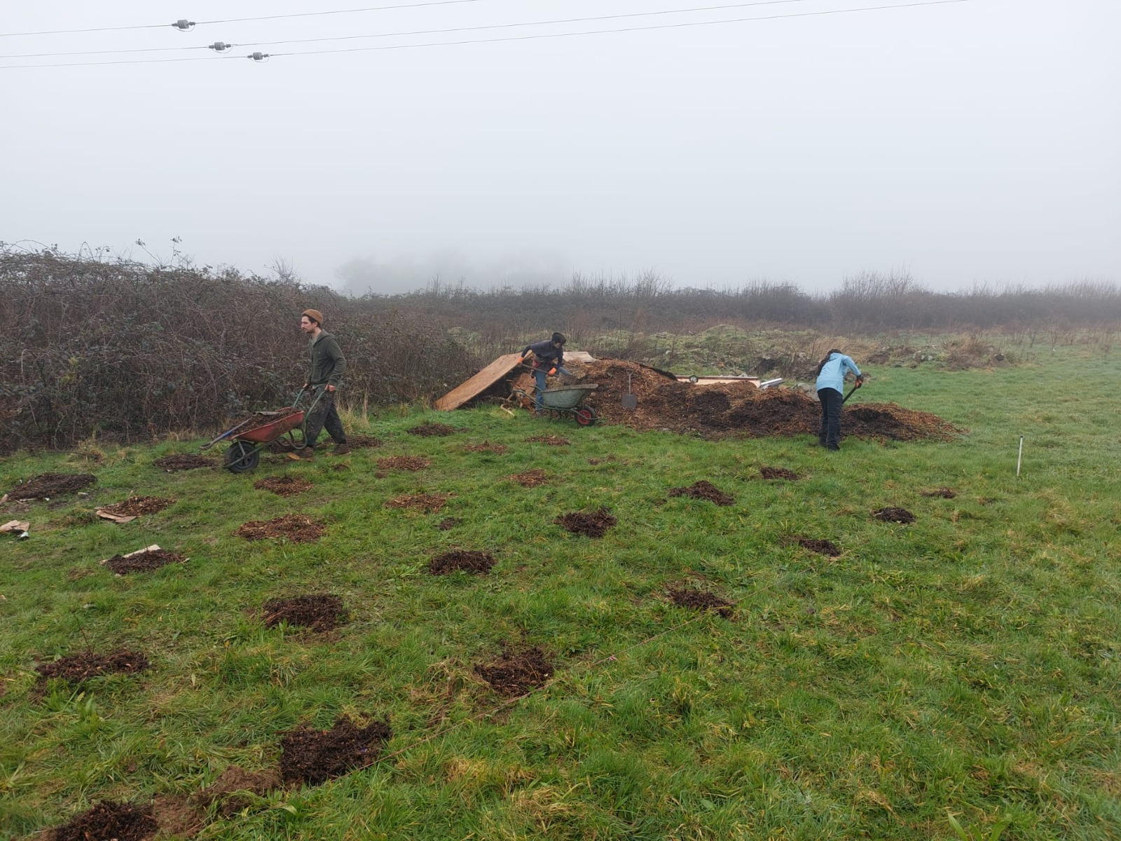
The Chestnut coppice in the Ten acre.
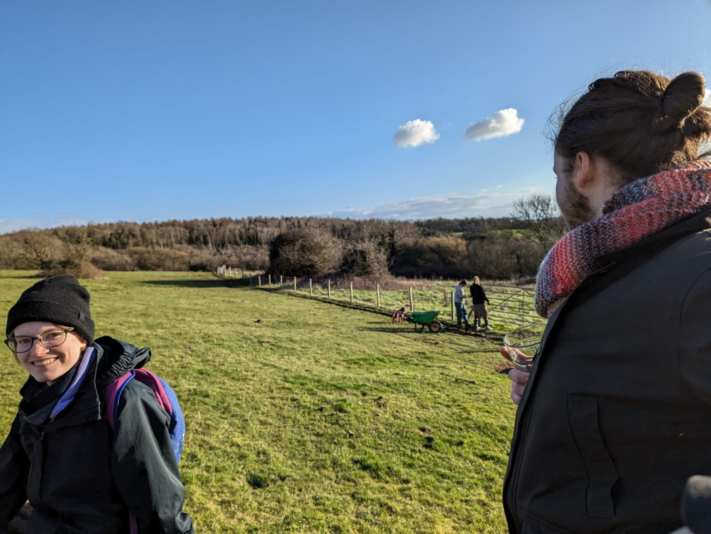
Coed y Fynnon planting
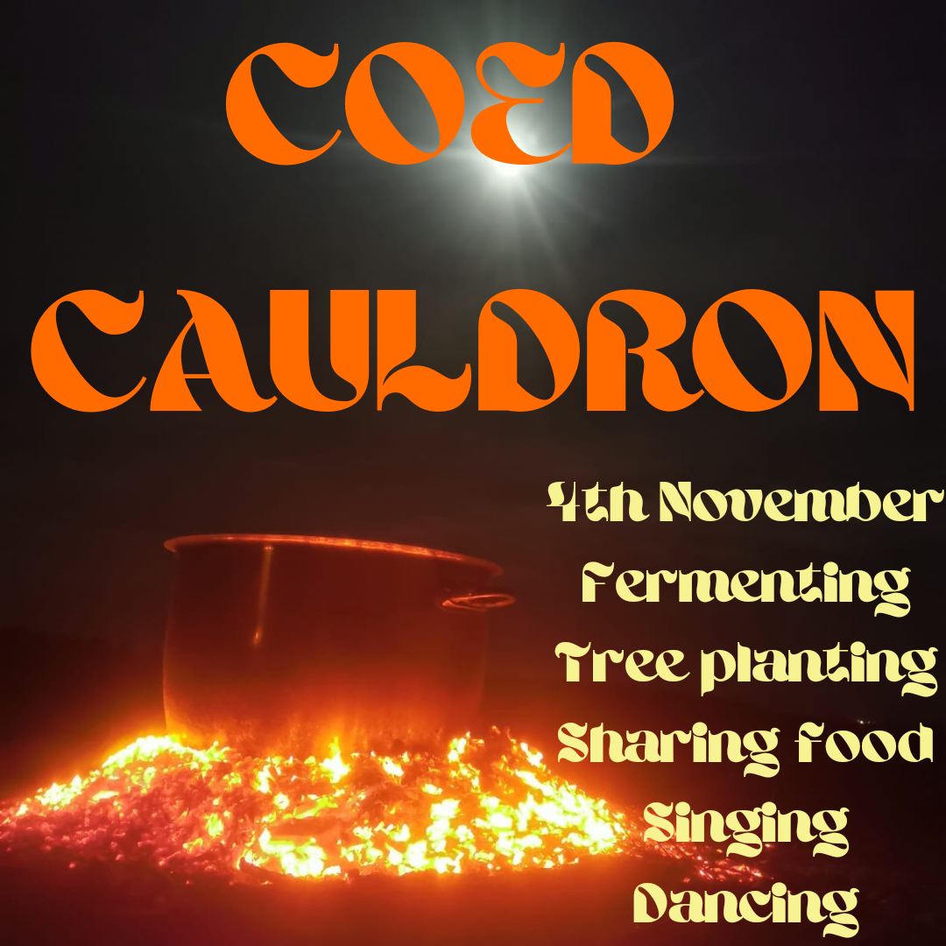
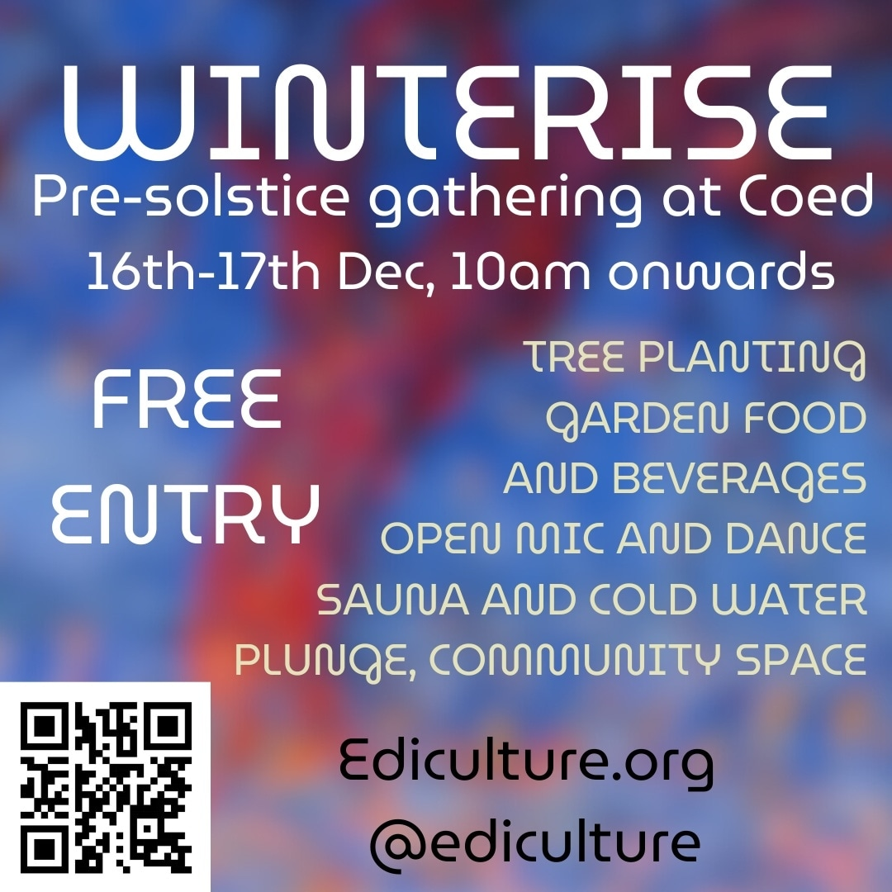
Posters from two of the events involving tree planting.

Trees now rooted in Coed Hills
This year the focus of the tree planting expanded to also tree care, starting in the autumn. We began our tree planting earlier than in previous years, getting many trees in the ground before the winter solstice, which was fortuitous because the ground was soft and dry enough to plant. A number of date changes for the post solstice plantings had to be changed because of the weather which made co-ordination of the days difficult. Despite this we managed to get in 9 planting days.

This year a lot of focus went into supporting the existing plantings to ensure that the trees survive well into the future

Nancy Evans and Coed Y Tor Trees
Whereas last year we sourced many of our trees from a variety of nurseries across the country, this planting season we focused on supporting local tree producers. We bought most of our trees from a new tree nursery called Coed Y Tor Trees, set up by Nancy Evans in Cowbridge. Nancy collects her seeds by hand from local trees providing provenance to the genetics of her seeds. We also sourced all of our woodchip for mulching the trees from Ewart Schofield’s tree surgery business in Cowbridge thereby reducing our carbon footprint. We were really impressed with the quality of Nancy’s trees and Ewart’s woodchip for the mulch, and we feel confident that the trees will grow really well.

BREAKDOWN OF TREES AND COSTS
- Coed y Tor supplied 119 sweet chestnut, 40 Downy birch, Established oak tree (£334)
- woodchip from ESA Tree care – 5 large deliveries (261£)
- Walnut tree company 30 sweet chestnuts grafted. ( £1230)
- 100 beech trees from Mount pleasant trees – (126£)
- 100 Hedging trees from Frank p Matthews – (£250)
- Empathy rootgrow – mycorrhizal inoculant – (£191)
- Ediculture – 80 apple trees – (£1600)
- Tree stakes, guards and ties – (£100)
- Transport for cardboard - £(20)
- Food and training time - £800 (£100 per day – covering a tutor and chef time to cook lunch from the gardens)
- £80 on food and drink expenses
.

Tree Planting Project: Sponsors and project partners
A huge thanks to Orchard Media and other Sponsors for the money to purchase trees and planting aids, to make this project possible. Details of what trees and where they were planted are detailed in our Full Description of Trees PDF.
SPONSORS
- Orchard Media (Thinkorchard.com)

NURSERIES
- Coed Y Tor (Nancy Evans)
- FPM Tree Nursery (Facebook.com/FrankPMatthewsLtd)
- Walnut tree company
- Mount pleasant trees
- Empathy rootgrow Ltd
- Ediculture (Ediculture.org)

How to get involved

ediculture.org
07507578885
Coed Hills Rural Art Space
St Hilary
Cowbridge
CF71 7DP

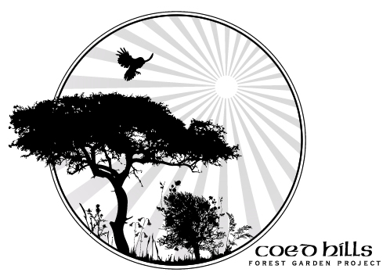

About Coed
Coed (pronounced ‘coyd’) is a Welsh word meaning “woods”. Birthed in 1997, Coed Hills Rural Artspace is one of Wales’ leading centres for sustainable living and the creative arts. The land is a sustainable community situated in the Vale of Glamorgan, around 8 miles west of Cardiff.
Residents in the community live on the land in a variety of dwellings including railway carriages, Mongolian Yurts, log cabins and straw bailed buildings. The whole site is run on alternative energy, including high-tech wind turbines and biomass underfloor heaters. There is an 8-acre market garden and a 2-acred forest garden on site which we thank everyone who has helped pour love and energy into.

Our Core Mission

Why we’re here

At the core of our heart is Sustainability, Permaculture, Ecology and Education. We continue to be a centre of education focused on nature, sustainability and traditional woodland skills and crafts, contributing to local tourism, employment and the rural economy.
We are working towards self-sufficiency in energy production: this will reduce our costs and our effect on the local and global environment, and serve as a living experiment in what is possible. We constantly explore and share what we learn both from cutting edge technology and from the knowledge and wisdom of the past.

Sharing natures’ magic

We grow food following Permaculture principles and aim to demonstrate ecological land use, low-impact living and artist creativity, as well as giving people the opportunity to experience and practise all these things for themselves.
As a social enterprise we offer a range of opportunities to people in the area: local organisations, schools, colleges, and a diverse range of individuals and families use our facilities for pursuits ranging from family camping weekends to wedding receptions and charity events.
We offer a unique conference venue, with artists’ workshops, art gallery, Permaculture gardens, sawmill, green woodwork area, full size solar-aligned stone circle, the first composting toilets in the Vale.

