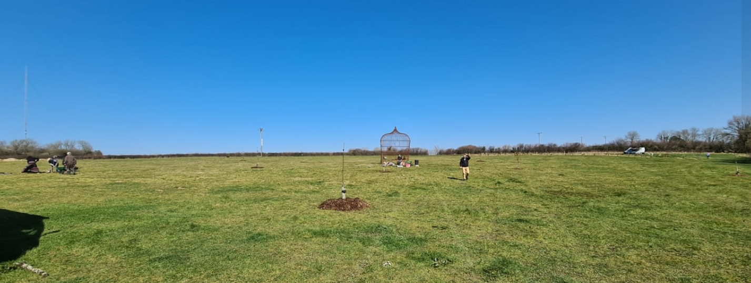

Tree Planting Project 2022/2023 Report
Extending our gratitude to the sponsors and volunteers who have helped
plant over 1200 trees during Winter 2022 and Spring 2023!

Days of planting
The first tree planting weekend began on 28th Jan, and the final weekend was on the 25th of Feb, with 4 other weekends inbetween totalling 12 days of planting. These weekends were enjoyed by many of the Coed residents plus about 30+ volunteers as we joined together to create greener spaces around the site of Coed Hills Rural Art Space. These were mostly local connections but we had a few turning up from Bristol and even Brighton!

As ever, we were amazed by the effort of the volunteers and deeply grateful to all who showed up. We couldn’t have done it without them! Prayers, dances, meals and plenty of hot drinks were shared with everyone who devoted time to these planting days.

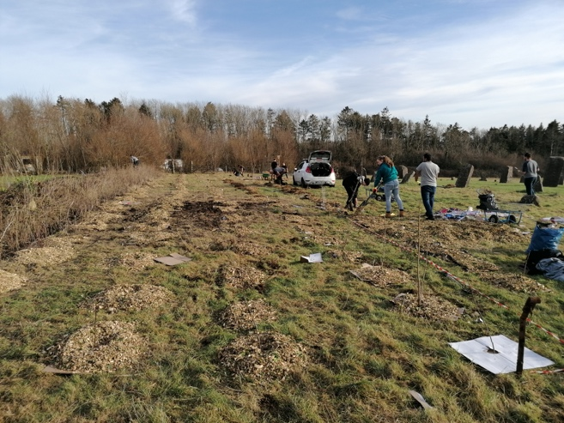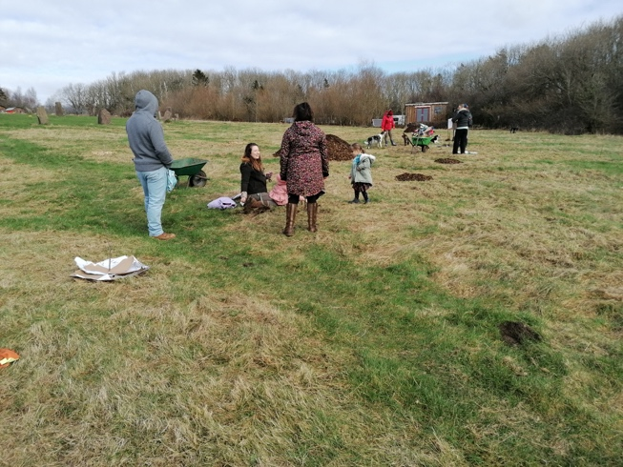

Trees now rooted in Coed Hills
This year the focus of the tree planting involved 3 major hedge/shelter belt plantings, plus a number of apples and chestnuts to expand what we already have at Coed.
The first weekend involved establishing a long beech hedge in the ten acre field next to the carpark, with over 400 plants. The second weekend involved establishing a shelterbelt of over 250 plants in the north of the stone circle field. A mix of alder, chestnut, silver birch, crab apple, elder, rowan, hawthorn and hazel were put in. The next weekend involved planting another shelterbelt/hedge along the west edge of the stone circle field of about 300 trees. This was a similar mix to the species above. The next weekend involved planting apples, pears, plums and chestnuts which were sourced through ediculture and the Agroforestry Research Trust, to plan for increased tree crop production. The next weekend was a planting of trees down at Coed Y Fynnon, an area of land fenced off to return to woodland. The final weekend involved filling in all the gaps across the site with trees from Jurassic plants.

Nancy Evans and Coed Y Tor Trees
Whereas last year we sourced many of our trees from a variety of nurseries across the country, this planting season we focused on supporting local tree producers. We bought most of our trees from a new tree nursery called Coed Y Tor Trees, set up by Nancy Evans in Cowbridge. Nancy collects her seeds by hand from local trees providing provenance to the genetics of her seeds. We also sourced all of our woodchip for mulching the trees from Ewart Schofield’s tree surgery business in Cowbridge thereby reducing our carbon footprint. We were really impressed with the quality of Nancy’s trees and Ewart’s woodchip for the mulch, and we feel confident that the trees will grow really well.
.

Tree Planting Project: Sponsors and project partners
A huge thanks to Orchard Media and other Sponsors for the money to purchase trees and planting aids, to make this project possible. Details of what trees and where they were planted are detailed in our Full Description of Trees PDF.
SPONSORS
- Orchard Media (Thinkorchard.com)

NURSERIES
- Coed Y Tor (Nancy Evans)
- FPM Tree Nursery (Facebook.com/FrankPMatthewsLtd)
- Agroforesty Research trust
- Ediculture (Ediculture.org)
- Greg Willow

How to get involved

ediculture.org
07507578885
Coed Hills Rural Art Space
St Hilary
Cowbridge
CF71 7DP

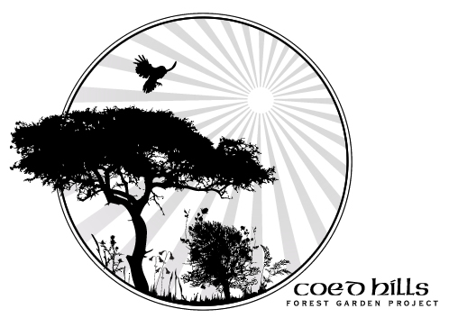

Meet Coed

About Coed
Coed (pronounced ‘coyd’) is a Welsh word meaning “woods”. Birthed in 1997, Coed Hills Rural Artspace is one of Wales’ leading centres for sustainable living and the creative arts. The land is a sustainable community situated in the Vale of Glamorgan, around 8 miles west of Cardiff.
Residents in the community live on the land in a variety of dwellings including railway carriages, Mongolian Yurts, log cabins and straw bailed buildings. The whole site is run on alternative energy, including high-tech wind turbines and biomass underfloor heaters. There is an 8-acre market garden and a 2-acred forest garden on site which we thank everyone who has helped pour love and energy into.

Our Core Mission

Why we’re here
At the core of our heart is Sustainability, Permaculture, Ecology and Education. We continue to be a centre of education focused on nature, sustainability and traditional woodland skills and crafts, contributing to local tourism, employment and the rural economy.
We are working towards self-sufficiency in energy production: this will reduce our costs and our effect on the local and global environment, and serve as a living experiment in what is possible. We constantly explore and share what we learn both from cutting edge technology and from the knowledge and wisdom of the ancients.

Sharing natures’ magic
We grow food following Permaculture principles and aim to demonstrate ecological land use, low-impact living and artist creativity, as well as giving people the opportunity to experience and practise all these things for themselves.
As a social enterprise we offer a range of opportunities to people in the area: local organisations, schools, colleges, and a diverse range of individuals and families use our facilities for pursuits ranging from family camping weekends to wedding receptions and charity events.
We offer a unique conference venue, with artists’ workshops, art gallery, Permaculture gardens, sawmill, green woodwork area, metalworking forge, full size solar-aligned stone circle, the first composting toilets in the Vale. The internationally renowned Sculpture Trail is currently undergoing woodland management and improvements.

