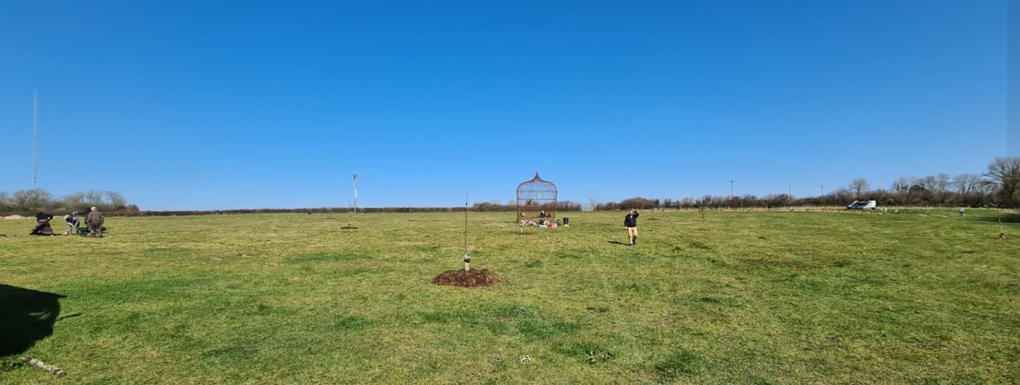

Tree Planting Project 2021/2022 Report
Extending our gratitude to the sponsors and volunteers who have helped
plant over 1400 trees during Winter 2021 and Spring 2022!

Days of planting
An incredible 12 days were enjoyed by many at Coed this 2021/22 season as we joined together to create greener spaces around the site of Coed Hills Rural Art Space.
We were absolutely blown away by all the hearts involved, those brave volunteers willing to make it out to plant trees at the coldest and darkest time of the year. Prayers, dances, meals and plenty of hot drinks were shared with everyone who devoted time to these planting days. About 60 volunteers were involved with the planting. These were mostly local connections but we had a few turning up from Bristol and even Brighton!

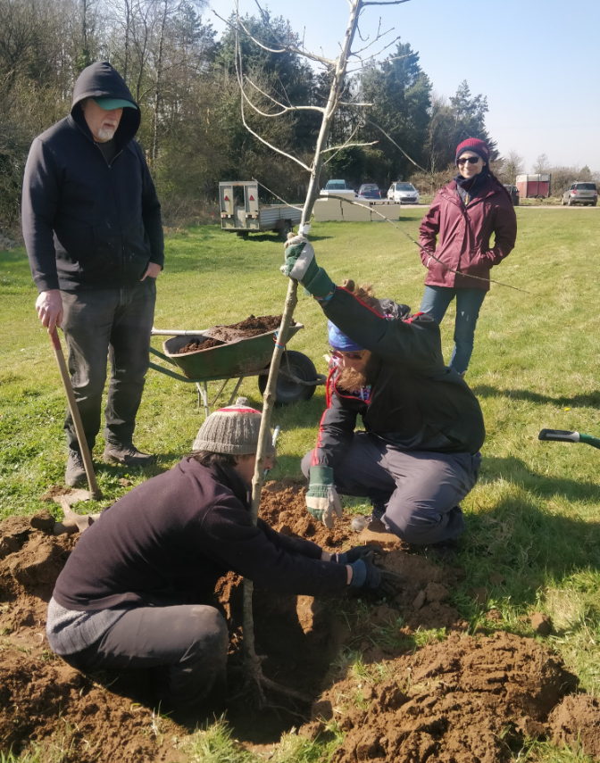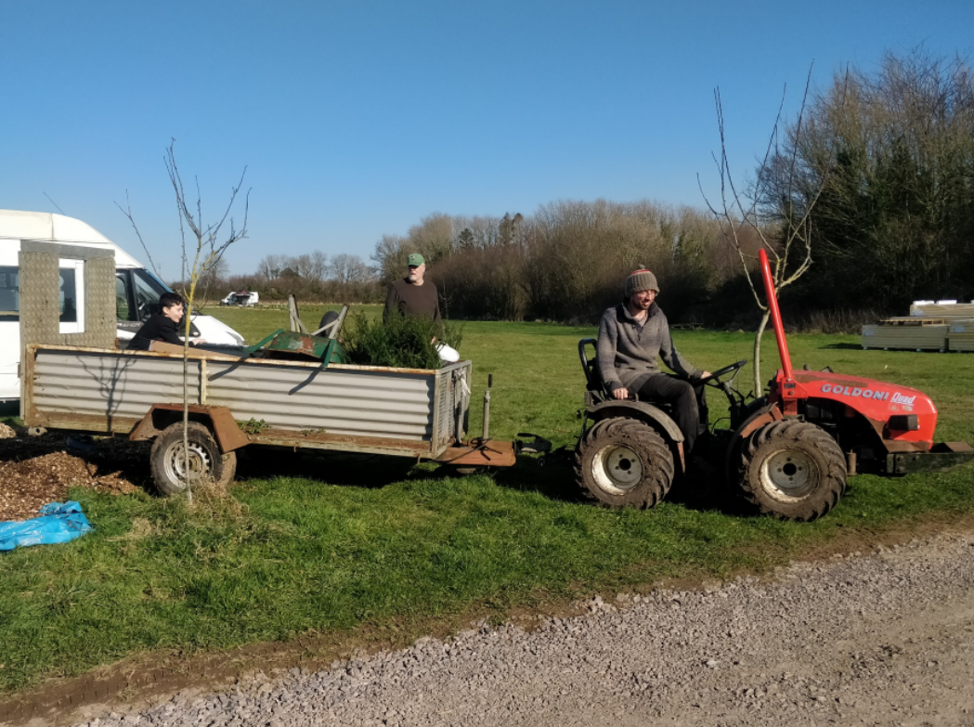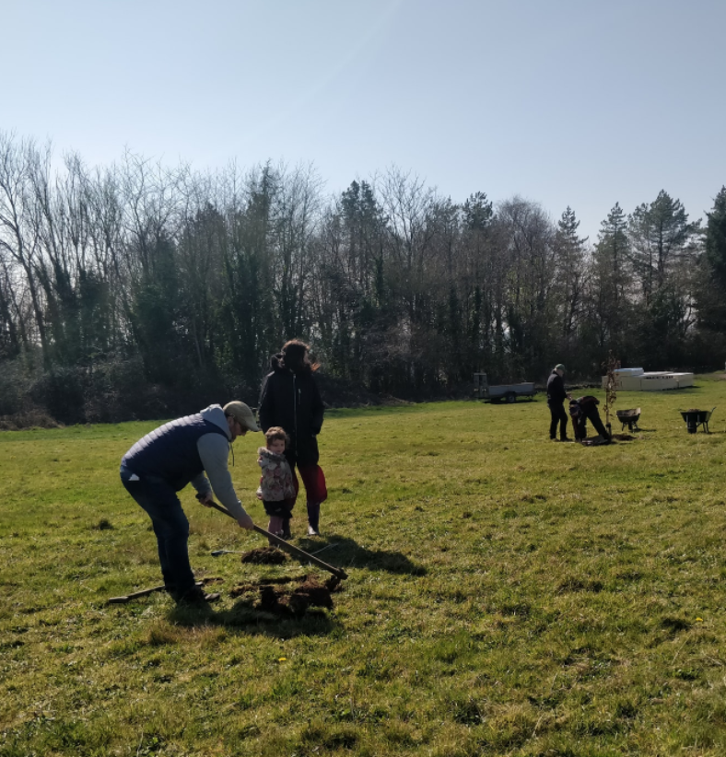

Trees now rooted in Coed Hills
The trees that we have planted have been carefully chosen to fit specific needs of the site, from hedges to fruit trees to full size majestic standards. Each tree has honourably brought its own flavour of life to the space and we are so pleased to have rehomed them.
In the 10-acre field there has been a shelter belt planted to help reduce interference from the windier days plus a new hedge line around the outskirts. The drive that connects the car park to the main event space has had many young trees planted in a beautiful geometric star that we are all looking forward to seeing flourish and grow amongst the wild flowers.

Tree Planting Project: Sponsors and project partners
A huge thanks to Orchard Media and other Sponsors for the money to purchase trees and planting aids, to make this project possible. Details of what trees and where they were planted are detailed in our Full Description of Trees PDF.
SPONSORS
- Orchard Media (Thinkorchard.com)
- Earth Star Community (Facebook.com/Earth-Star-Community-2354157314861284)

NURSERIES
- Jurasic Plants (Jurassicplants.co.uk)
- FPM Tree Nursery (Facebook.com/FrankPMatthewsLtd)
- Mount Pleasant (Mountpleasantfarmandforestry.co.uk)
- Ashridge Nurseries (Ashridgetrees.co.uk)
- EdiCulture (Ediculture.org)

For more detail as to the specific locations of the trees and the planting sequence, please see the tree description document

Honouring our existing land
We continue to nurture and watch the forest garden and woodland blossom in brighter colours this year through pruning and on-going care and maintenance. We are progressively increasing the diversity which adds to the overall health and balance of the ecosystem. If you are intrigued to know the species names of the trees we have planted a separate document has been created.

Exciting 2022/23 projects
Can you imagine Wales’ first homegrown banana?! By utilizing the slowly increasing temperature of our area and combining it with extended land, new opportunities are unfolding as you read this. We are introducing community allotments and a very special growing space…

Subtropic Paradise
We will be erecting a temporary large polytunnel to experiment with a new growing space. Our vision is to learn from and grow subtropical trees and plants. So not only will the forest garden and 10-acre field provide the local community with quality food, but it is now offering the chance to connect to different species of fruits and vegetables that may not usually grow in our climate here in Wales.

Growing greener communities
We are very excited to share this journey with you and if this ignites your spark of curiosity be sure to get involved in shaping these spaces.

How to get involved
website: ediculture.org
Give us a bell: 07507578885
Write to us: Coed Hills Rural Art Space, St Hilary, Cowbridge, CF71 7DP

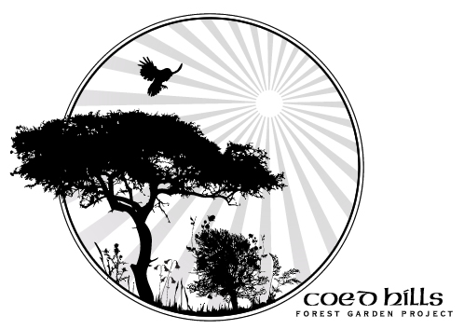

Meet Coed

About Coed
Coed (pronounced ‘coyd’) is a Welsh word meaning “woods”. Birthed in 1997, Coed Hills Rural Artspace is one of Wales’ leading centres for sustainable living and the creative arts. The land is a sustainable community situated in the Vale of Glamorgan, around 8 miles west of Cardiff.
Residents in the community live on the land in a variety of dwellings including railway carriages, Mongolian Yurts, log cabins and straw bailed buildings. The whole site is run on alternative energy, including high-tech wind turbines and biomass underfloor heaters. There is an 8-acre market garden and a 2-acred forest garden on site which we thank everyone who has helped pour love and energy into.

Our Core Mission

Why we’re here
At the core of our heart is Sustainability, Permaculture, Ecology and Education. We continue to be a centre of education focused on nature, sustainability and traditional woodland skills and crafts, contributing to local tourism, employment and the rural economy.
We are working towards self-sufficiency in energy production: this will reduce our costs and our effect on the local and global environment, and serve as a living experiment in what is possible. We constantly explore and share what we learn both from cutting edge technology and from the knowledge and wisdom of the ancients.

Sharing natures’ magic
We grow food following Permaculture principles and aim to demonstrate ecological land use, low-impact living and artist creativity, as well as giving people the opportunity to experience and practise all these things for themselves.
As a social enterprise we offer a range of opportunities to people in the area: local organisations, schools, colleges, and a diverse range of individuals and families use our facilities for pursuits ranging from family camping weekends to wedding receptions and charity events.
We offer a unique conference venue, with artists’ workshops, art gallery, Permaculture gardens, sawmill, green woodwork area, metalworking forge, full size solar-aligned stone circle, the first composting toilets in the Vale. The internationally renowned Sculpture Trail is currently undergoing woodland management and improvements.

