TREE REPORT 2022

– DESCRIPTIONS AND DETAILS

Coed Hills Rural Art Space has now over 1400 extra trees planted around the site thanks to the volunteers and sponsors during 2021/2022.

Trees purchased:

ORGANIC HEDGING AND TREES

600 trees of Hawthorn, Blackthorn, Rowan, Cherry Plum, Buckthorn, Alder Buckthorn, Field maple, Common Pear, Downy Birch, Hazel, Goat Willow, and Holly. Half of these were paid for by Orchard Media

WOODLAND TRUST
80 hedging trees from the
Woodland Trust.

JURRASIC PLANTS

Planted around the gardens. These trees have been selected for their use in bee keeping and providing food for wildlife at unusual times of the year.

Chimonanthus praecox – winter sweet
Blepharocalyx cruckshanksii - Heaven Scent Evergreen shrub
Daphniphyllum macropodum
lerodendrum trichotomum
Staphylea pinnata
Vaccinium corymbosum
Vitis labrusca Concord
Ficus carica 'Scone' - Figtree Scone
Distylium racemosum - Isu Tree
Crinodendron patagua
Cotoneaster bullatus
Corylopsis sinensis
Fragrant winter hazel
Caryopteris incana
Camellia japonica
Decaisnea fargesii
Diospyros virginiana
styrax japonicus
Styrax formosanus
Styrax obassia
Sapindus mukorossi
Sophora tetraptera
Sophora microphylla
Magnolia sieboldii
Maackia amurensis
Virginian Witch Hazel
Japanese Medlar
Diospyros lotus
Cornus capitata
Cercis siliquastrum
Catalpa bignonioides
Aronia prunifolia
Araucaria araucana – monkey puzzle
albizia julibrissin - Silk tree
Aesculus turbinata
Aesculus indica
Aesculus parviflora - Bottle brush
Actinidia arguta Ananasnaya
Acca sellowiana
Acacia dealbata

FPM TREE NURSERY

MORE TREES FOR THE FOREST GARDEN EXTENSION + MORE TREES FOR BEES – PLANTED IN THE CROFTER / AROUND THE BARN

Prunus Catherine
Prunus Kofugen
Prunus Royal Flame
Prunus Spire
Prunus x per Spring Glow

PLANTED IN THE WOODLAND
Betula alba pendula (Silver Birch x 100)
Alnus glutinosa (Common Alder)
Ilex aquifolium (Holly)
Malus sylvestris (Crab Apple)
Fagus sylvatica (Beech)

PLANTED IN THE EXTENDED FOREST GARDEN

Frank P Matthews Tree order Feb 2022

Elder (Sambucus) Haschberg
Pears:
Barnett
Beurre Superfin
Black Worcester
Blakeney Red
Brandy (Perry)
Catillac
Fondante d'Automne
Gin (Perry)
Green Horse (Perry)
Hellens Early (Perry)
Humbug (Stripy)
Jargonelle
Josephine de Malines
Judge Amphlet
Louise Bonne of Jersey
Obelisk
Packham's Triumph
Pitmaston Dutchess
Red Pear (Perry)
Sensation
Thorn (Perry)
Williams' Bon Chrétien
Winnal Longdon (Perry)

Asian Pear (Pyrus) Kumoi

Plums:
Blaisdon Red
Edda
Ferbleur
Guinevere
Haganta
Katinka
Kea
Queens Crown
Reeves
Tophit Plus
Toptaste® Kulinaria
Warwickshire Drooper

Walnut:
Fernette x2
Fernor x2
Lara x2
Tulare x2
Mulberry (Morus) Chelsea (King James)
Mulberry (Morus) Giant Fruit

MOUNT PLEASANT

Planted around the forest garden and in the woodland

Yew x20
Castanea sativa (Sweet Chestnut) x100
Eleagnus ebbengei x24
Sorbus vilmorini x4
Sorbus Joseph rock x4
Magnolia Leonard messell x2
Beech x100
Holly x24
Bird Cherry x20
Silver birch x100
Alder x100
Box x24

ASHRIDGE NURSERIES x EARTH STAR COMMUNITY

Planted around the barn, in the stone circle and in the 10 acre field

Oak, Sessile (x12)
Cedar, Western Red (x51)
Poplar, Black (x50)

EDICULTURE

Planted in the forest garden and the 10 acre field

Many types of Apples (x80)
Cherries, (x10
Pears (x20)
Plums (x20)

PLANTING WEEKENDS
from JAN 2022 – to MARCH 22

Please see the numbers on the map below to reference where we were planting and what the intention was
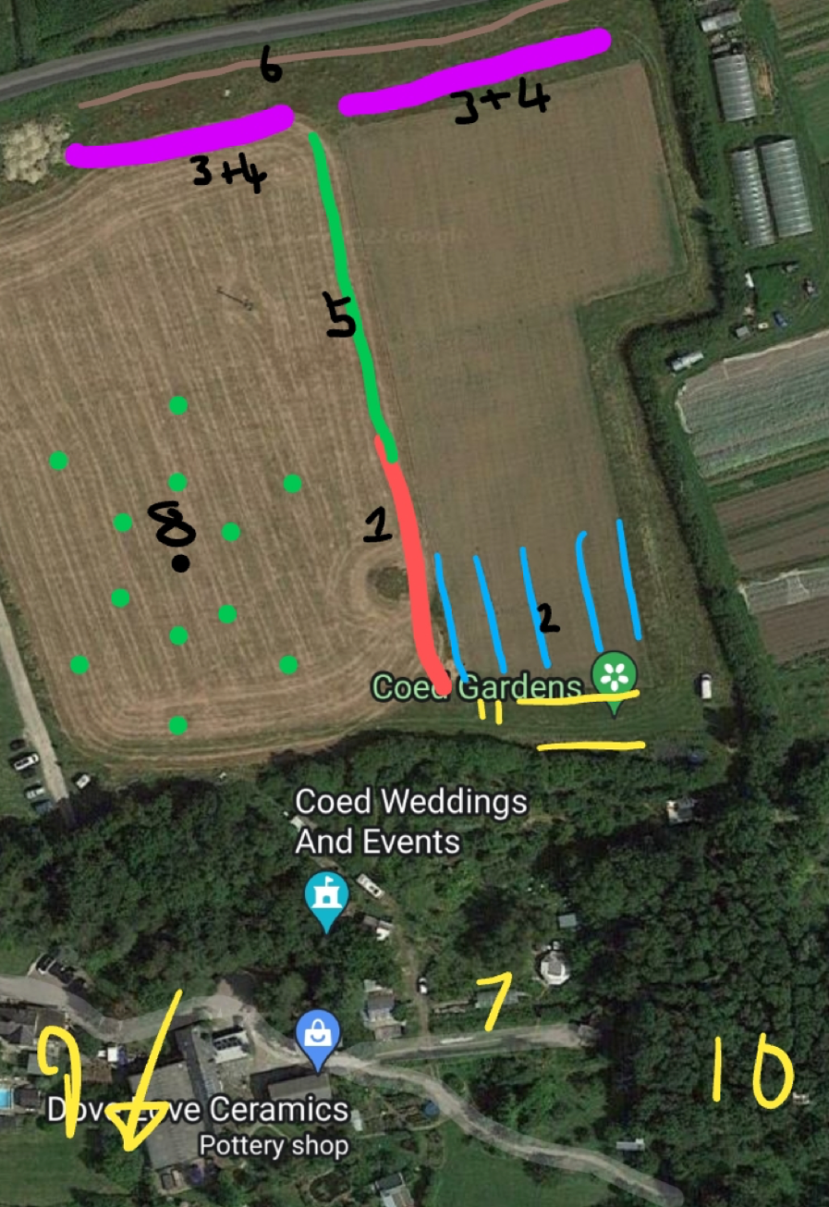

SITES 1 and 2
First planting Weekend –

20 people ish, 400+ trees into shelterbelt , 5 m wide, plus 100+ fruit trees

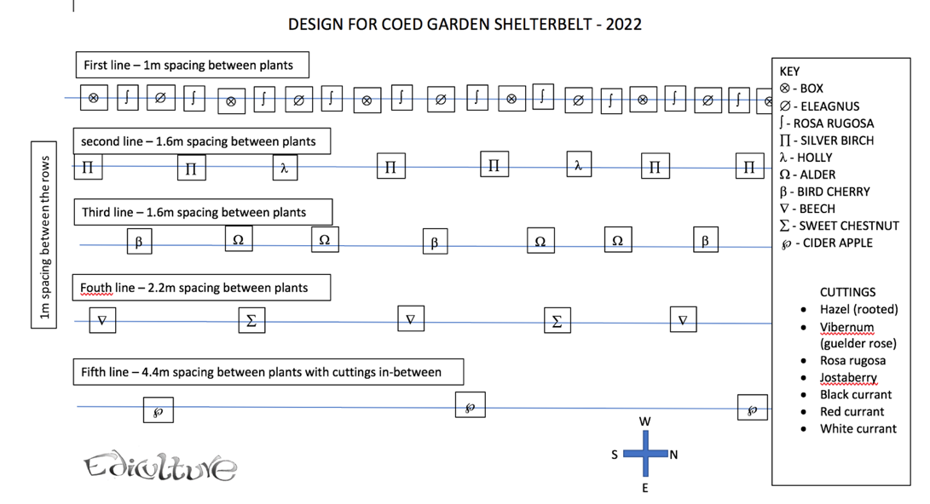

– SITES 3 + 4

Second planting weekend plus third planting weekend

Another shelterbelt, based on same principles of first one.

The part behind the market garden was not mulched with bio digester by-product due to certification issues on organic land.

Atlantic college to help. (20+ students helped plant) Many thanks to them for their support.

Plus 20 volunteers from community.

400 or so trees planted.

SITE 5 – scots organic hedge, 450+ planted by the market garden staff

SITE 6 – final community day with Aberfan volunteers – 100 tall hedging trees, cedar and poplar

SITE 7 – trees from Jurassic plants (unusual ornamentals good for bees put into pots for growing on for a year – 40+

SITE 8 +9 – final planting weekend on equinox – oaks and yews - 32

SITE 10 – leftover beech and silver birch into woodland - 50

SITE 11 – final fruit trees into new allotments - 30

Concept behind the shelterbelt at Coed Gardens 2022

2020, the year the general population were stopped in their tracks, got scared about food supplies, general uncertainty reigned. Those who were already engaged with land based living, carried on, but not quite business as usual: instead, a great resurgence of interest was sparked, and we at Coed noticed the local community looking to buy more plants, seeds, veg boxes, indeed everything we had to offer, as it looked like the solution to the situation.

So we decided to take on some more land. We chose the most obvious space, what we refer to as the “10 acre” field. This land needed a wind break from the predominant west winds. It also needed soil improvement, which has already begun thanks to Scotty the market gardener, who arranged the local farmer to plough and power-harrow the field, from which he could so green manures: a mix of mostly clovers and chicory.

Orchard Media, a local media company based in Cardiff had got in touch in 2021 to donate money towards tree planting. This money has covered the costs of the trees and the planting resources.

